TASK Using the clone tool

Cloning Exercise 1

Use fruit.jpg and choose the rubber stamp tool and a brush size that is not too large..

- Repair the Pear - Option click on a good part of the pear (this selects a nice area of the Pear to clone). Move to the bruise on the pear and click the Rubber Cloning tool to replace the bruise with green.
Try with another object. Option Click this turns white and picks up the area
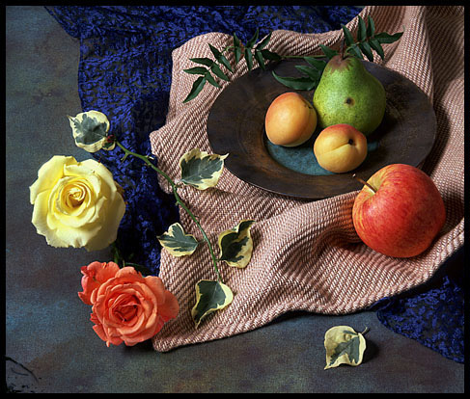
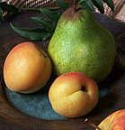

Cloning Exersize 2 : From 18 yrs to 48 yrs in 15 minutes!
Using The Clone tool
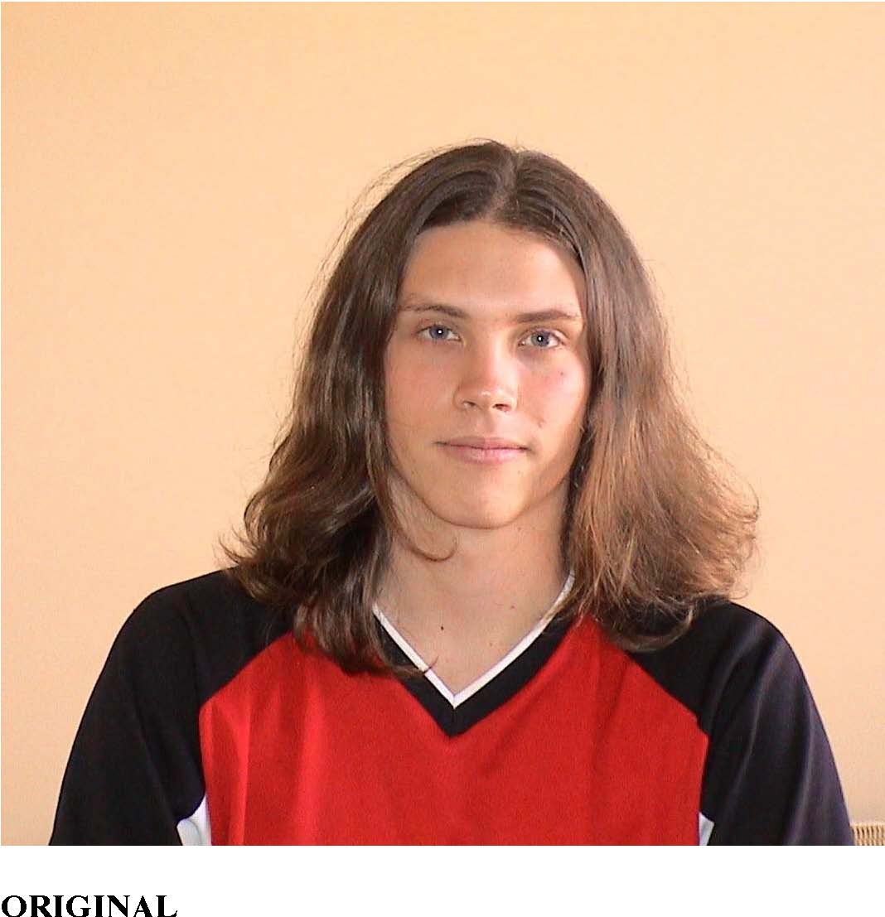
Take a photograph of yourself or use image
APS129 image.psd

1. Hold down the Alt key over your forehead and sample the image using the clone tool
clone
2. Blend forehead skin colour into hair
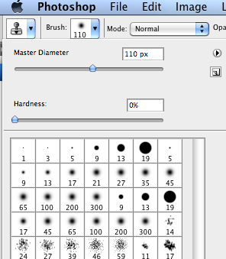

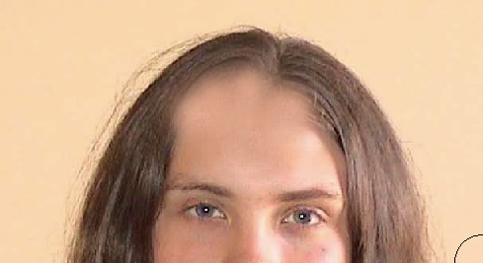

3. Blend shirt colours over long hair on shoulders

4. Find a photo with ears showing; Using the Freehand marquee tool, copy and paste ears from another photo
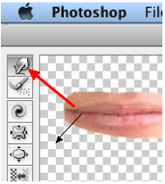

5. Using the Freehand marquee tool copy and paste mouth, to a new layer. Use the Liquify filter t (using the pucker or forward warp on the mouth to make it look older )

6. Copy and paste wrinkles on forehead, cheeks & neck from another photo Adjust transparency and feather to blend these into the image softly

7. Using the Paintbrush – smear effect
Smear corners of mouth, tip of nose & eyelids to make droopy look

8. Paintbrush – crayon tool
Wrinkles under eyes & corner of eyes. Use “smudge” tool to soften the line
9. Paintbrush – spray can Fine spray for beard stubble effect
Texture Effects-elephant skin.

10. Apply marquee to face skin area and apply effect to “wrinkle” skin

Transparency tool
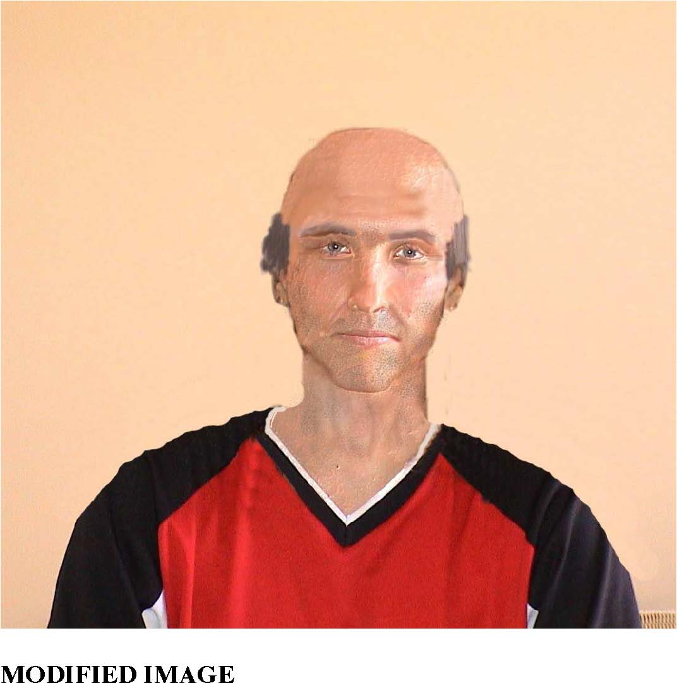
- Draw freehand marquee over eyebrows and remaining hair.
- Copy to new layer.

Save as surname_oldman.psd or (.jpg)

Cloning Exersize 3

Open APS129_image2.png
Carry out the modifications required



Remove the girl from the picture

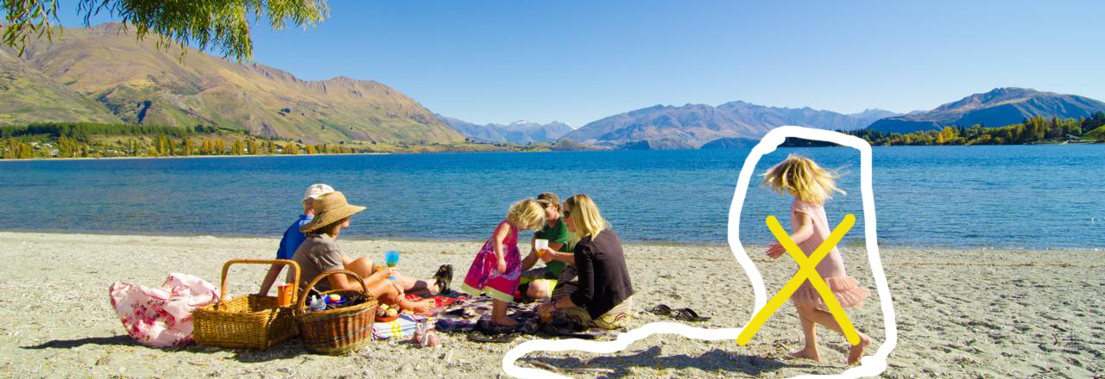

Additional - Remove the palm tree leaves, or place a palm tree on the sand!



